GMF bibliotekoje gautos naujos knygos 2015 gruodžio mėn.

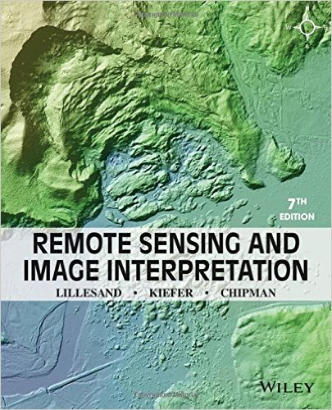

Remote Sensing and Image Interpretation 7th Edition
by Thomas Lillesand (Author), Ralph W. Kiefer (Author), Jonathan Chipman (Author)

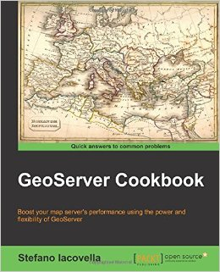

About This Book
Optimize your vector and raster data with GeoServer's advanced configuration
Explore the latest GeoServer modules that make managing styles and monitoring and configuring your server a lot easier
A pragmatic guide to find your way through the world of GeoServer
Who This Book Is For
This book is ideal for GIS experts, developers, and system administrators who have had a first glance at GeoServer and who are eager to explore all its features in order to configure professional map servers. Basic knowledge of GIS and GeoServer is required

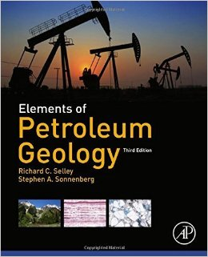
Elements of Petroleum Geology, Third Edition by Selley, Richard C., Sonnenberg, Stephen A. 3rd edition (2014) Hardcover Hardcover – 1601
by Richard C., Sonnenberg, Stephen A. Selley (Author)

This book is a usefulprimer for geophysicists, geologists, and petroleum engineers in the oil industry who wish to expand their knowledge beyond their specialized area. It is also an excellent introductory text for a university course in petroleum geoscience.
Elements of Petroleum Geology begins with an account of the physical and chemical properties of petroleum, reviewing methods of petroleum exploration and production. These methods include drilling, geophysical exploration techniques, wireline logging, and subsurface geological mapping. After describing the temperatures and pressures of the subsurface environment and the hydrodynamics of connate fluids, Selley examines the generation and migration of petroleum, reservoir rocks and trapping mechanisms, and the habit of petroleum in sedimentary basins. The book contains an account of the composition and formation of tar sands and oil shales, and concludes with a brief review of prospect risk analysis, reserve estimation, and other economic topics.

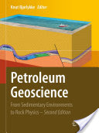

This comprehensive textbook presents an overview of petroleum geoscience for geologists active in the petroleum industry, while also offering a useful guide for students interested in environmental geology, engineering geology and other aspects of sedimentary geology. In this second edition, new chapters have been added and others expanded, covering geophysical methods in general and electromagnetic exploration methods in particular, as well as reservoir modeling and production, unconventional resources and practical petroleum exploration.

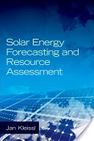

Solar Energy Forecasting and Resource Assessment is a vital text for solar energy professionals, addressing a critical gap in the core literature of the field. As major barriers to solar energy implementation, such as materials cost and low conversion efficiency, continue to fall, issues of intermittency and reliability have come to the fore. Scrutiny from solar project developers and their financiers on the accuracy of long-term resource projections and grid operators’ concerns about variable short-term power generation have made the field of solar forecasting and resource assessment pivotally important. This volume provides an authoritative voice on the topic, incorporating contributions from an internationally recognized group of top authors from both industry and academia, focused on providing information from underlying scientific fundamentals to practical applications and emphasizing the latest technological developments driving this discipline forward.

